**SUPPLEMENTARY MATERIAL 3**

*Choosing between zero-inflated and non-zero-inflated models and model validation*

A preliminary *non-zero inflated GLMM assuming a Poisson distribution* was fitted using the *lme4* package (Bates et al., 2015). However, this preliminary model did not pass the overdispersion test in the *Performance* package (Lüdecke et al., 2021; Dispersion ratio = 2.946, X² = 1873.710, p <0.001), in other words, dispersion in this model is bigger than assumed by the theoretical distribution. In addition to that, zero-inflation check from *Performance* package also point out that the model under fitted zeros with the default tolerance of 0.05 (Observed zeros = 575, Predicted zeros = 288, Predicted/observed ratio = 0.50). As dispersion and zeros are issued for our preliminary models, we have decided to test the performance of more complex models using zero-inflated GLMM.

As the glmmTMB package (Brooks et al., 2017) provides great flexibility to perform zero-inflated and non-zero -inflated GLMMs, we decided to perform all analyses to assess the role played by management plans in threatened species richness using the glmmTMB package. By using a unique package, we avoid any potential operational issues that might occur from different parameter estimators. For instance, the glmmTMB package uses the TMB optimiser while the *lme4* package uses several other optimisers but TMB. In addition to that, the glmmTMB package allows us to perform zero-inflated and non-zero inflated GLMMs models, so we could perform all analyses using a unique package.

Finally, using the glmmTMB, we construed three models:

1. Non-zero-inflated GLMM Poisson distributed.
2. Zero-inflated GLMM Poisson distributed assuming an equal probability for zeros across all protected areas.
3. Zero-inflated GLMM Poisson distributed assuming zeros as a function of the protected area's size.

These three models were compared using AIC (Table S3.1).

Table S3.1. Model comparison among different zero-inflated distributions. The “ziformula” is the function argument to specify the structure of zeros in the glmmTMB models.

|  |  |  |  |  |
| --- | --- | --- | --- | --- |
| Model structure: Richness ~ log(Size)+ManPlan | | | | |
| Model | **Zero inflated (ziformula)** | **k** | **AIC** | **ΔAIC** | |
| Size related zeros | ~Area | 11 | **2589.27** | **0.0** | |
| Equal probability zero inflated | ~1 | 10 | 2594.14 | 4.86 | |
| Non-zero inflated | ~0 | 9 | 2595.38 | 6.10 | |

Best model “*Richness ~ log(Area) + Year + Man.Plan + HFI2009 + HFItrend + Dist.Reser.Inst.*” also attends the minimal requirements for GLMM: Uniformity, dispersion and outliers. See table S3.2 and figure S3.1.

Table S3.2. Model validation of the best zero-inflated GLMM in Figure 2.

|  |  |  |  |
| --- | --- | --- | --- |
| Test | Test / Statistics | Value | p-value |
| Uniformity | One-sample Kolmogorov-Smirnov test (D) | 0.03 | 0.35 |
| Dispersion | Dispersion | 0.85 | 0.81 |
| Outliers | Number of outliers | 5 | 0.67 |

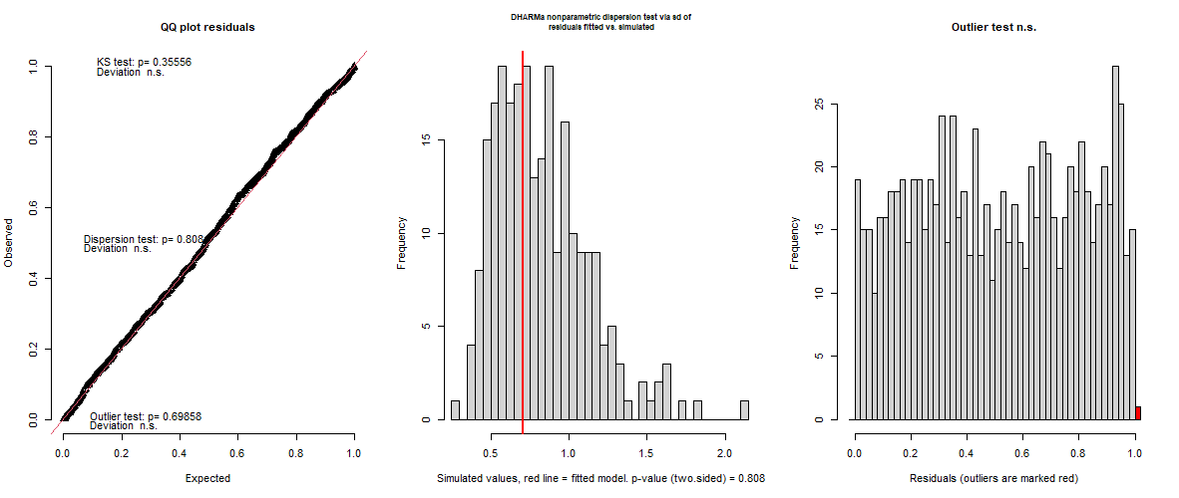

Figure S3.1. The default output of residual analyses performed by DHARMa package is provided for the best zero-inflated GLMM. From left to right: QQ-plot representing expected vs. observed values, simulated dispersion and fitted model dispersion and outlier test. “n.s.” means “non-significant” (*p* >0.05).

Similarly, to the zero-inflated GLMM, the global model used to predict the presence of the management plan also fitted the minimum requirements: Uniformity, dispersion and outliers. See table S3.3 and figure S3.2.

Table S3.3. Model validation of the global model used to predict the presence of management plan in Figure 4.

|  |  |  |  |
| --- | --- | --- | --- |
| Test | Test / Statistics | Value | p-value |
| Uniformity | One-sample Kolmogorov-Smirnov test (D) | 0.03 | 0.38 |
| Dispersion | Dispersion | 1.00 | 0.91 |
| Outliers | Number of outliers | 10 | 0.24 |

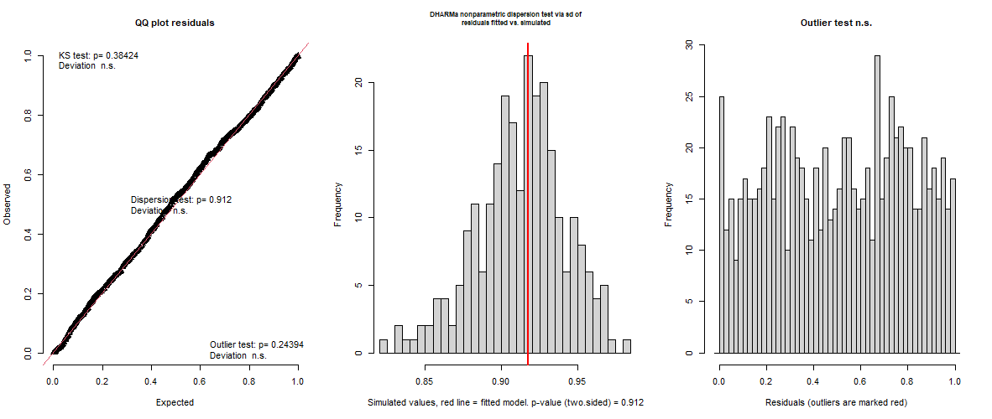

Figure S3.2. The default output of residual analyses performed by DHARMa package is the global model used to predict the presence of the management plan in Figure 4. From left to right: QQ-plot representing expected vs. observed values, simulated dispersion and fitted model dispersion and outlier test. “n.s.” means “non-significant” (*p* >0.05).

*Predicting the presence of management plan: There is no difference in the estimated slopes including or excluding threatened species richness.*

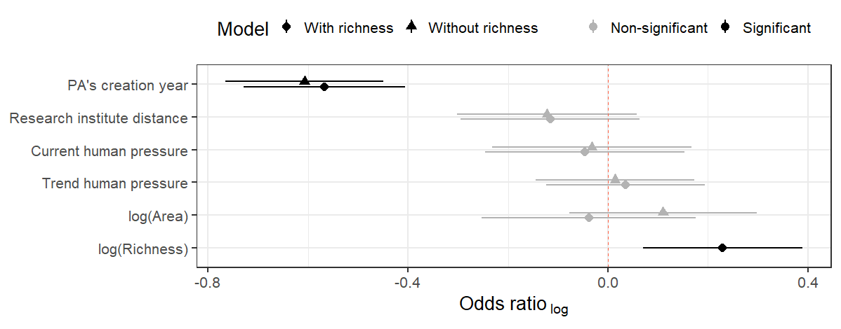

Figure S3.3. Models with and without threatened flora species richness reach similar results on the extent to which size, year of creation and anthropogenic pressure predict the presence of a management plan. Similarly to figure 3, the extent to which different variables contribute to predict the presence of a management plan in a PA is represented along their standard errors. Estimated slopes of models accounting and non-accounting for the threatened flora species richness are paired to highlight that both reach the same conclusion: the year of creation of the PAs is the single and most important variable to predict the presence of a management plan among our variables.

*Minimum distance to research centres*

The minimum distance was estimated from Brazilian public universities (IESs) for two reasons. First, the IESs are responsible for the major of the scientific publication in Brazil as research institutes focused on biodiversity are limited to a few dozen. Second a public database of brazilian public universities is provided by the Ministry of Education are freely available at <https://dados.gov.br/dataset/instituicoes-de-ensino-superior>. Existing information provided by the Ministry of Education include the administrative head office of 2,365 Brazilian IESs and their respective postal code. Because research activities by private IES is near to despresive, we only considered public the 259 public IES in our database. Then, we used the cepR package (McDonnell, 2020) to extract the geographic coordinates from postal code of each public IES which returned an intermediate table named “Public IES latlong.csv”. This intermediate table is available along the supplementary material resources and was used in the main script in our analyses (supplementary material S2). Finaly, the distance of the centroid of each protected area (PA) for each one of the public IES was calculated using the Vincenty (ellipsoid) method because it was the most accurate in the geosphere package (Hijmans, 2021). All procedures are available in the supplementary material 2.

*Full competing models*

A list of full competing models used in the model selection of table 1 is provided.

**Table S3.4. Competing explanatory models for threatened species richness and presence of management plans. Models are informed according to the degrees of freedom (df), Akaike Criteria Information (AIC), and model’s AIC weights and cumulative weight (Cum. weight). Models are ranked from lowest to higher AIC. The models show strong support for the presence of management plans to explain species richness. Only the ten best model are presented and compared with null model. Full competing models are listed in Supplementary material (S3). Variables are logarithm of PA’s size (*log(Area)*), year of creation (*Year*), presence of management plan (*Man.Plan*), existing and trend of the anthropogenic pressure (*HFI2009* and *HFItrend*, respectively), as well as Distance to research Institute (*Dist. Resear. Inst*). The null model was added to comparison and is indicated accordingly.**

| **Model** | **df** | **AIC** | **ΔAIC** | **Weight** | **Cum. weight** |
| --- | --- | --- | --- | --- | --- |
| *log(Area) + Year + Man.Plan + HFI2009 + HFItrend + Dist.Reser.Inst.* | 11 | 2589.27 | 0.00 | 0.35 | 0.35 |
| *log(Area) + Year + Man.Plan + HFItrend+ Dist.Reser.Inst.* | 10 | 2590.19 | 0.92 | 0.22 | 0.57 |
| *log(Area) + Year + Man.Plan + HFI2009+ HFItrend* | 10 | 2590.96 | 1.69 | 0.15 | 0.72 |
| *log(Area) + Year + Man.Plan + HFI2009+ Dist.Reser.Inst.* | 10 | 2591.64 | 2.36 | 0.11 | 0.83 |
| *log(Area) + Year + Man.Plan + Dist.Reser.Inst.* | 9 | 2592.30 | 3.02 | 0.08 | 0.91 |
| *log(Area) + Year + Man.Plan + HFItrend* | 9 | 2594.66 | 5.39 | 0.02 | 0.93 |
| *log(Area) + Year + Man.Plan + HFI2009* | 9 | 2595.12 | 5.85 | 0.02 | 0.95 |
| *log(Area) + Year+ HFItrend+ Dist.Reser.Inst.* | 9 | 2595.43 | 6.16 | 0.02 | 0.97 |
| *log(Area) + Year+ HFI2009+ HFItrend+ Dist.Reser.Inst.* | 10 | 2595.72 | 6.45 | 0.01 | 0.98 |
| *log(Area) + Year + HFI2009 + HFItrend* | 9 | 2597.62 | 8.35 | 0.01 | 0.99 |
| *log(Area) + Year+ Dist.Reser.Inst.* | 8 | 2597.87 | 8.59 | 0.00 | 0.99 |
| *log(Area) + Year+ HFI2009 + Dist.Reser.Inst* | 9 | 2598.42 | 9.15 | 0.00 | 0.99 |
| *log(Area) + Year + Man.Plan* | 8 | 2599.04 | 9.76 | 0.00 | 1.00 |
| *log(Area) + Year + HFItrend* | 8 | 2599.83 | 10.56 | 0.00 | 1.00 |
| *log(Area) + Year + HFI2009* | 8 | 2602.04 | 12.77 | 0.00 | 1.00 |
| *log(Area) + Year* | 7 | 2604.51 | 15.23 | 0.00 | 1.00 |
| *log(Area) + Man.Plan + HFI2009+ HFItrend+ Dist.Reser.Inst.* | 10 | 2608.93 | 19.66 | 0.00 | 1.00 |
| *log(Area) + Man.Plan + HFItrend + Dist.Reser.Inst.* | 9 | 2609.47 | 20.20 | 0.00 | 1.00 |
| *log(Area) + Man.Plan + HFI2009+ HFItrend* | 9 | 2612.42 | 23.14 | 0.00 | 1.00 |
| *log(Area) + Man.Plan + HFI2009+ Dist.Reser.Inst.* | 9 | 2612.67 | 23.39 | 0.00 | 1.00 |
| *log(Area) + Man.Plan + Dist.Reser.Inst.* | 8 | 2612.92 | 23.64 | 0.00 | 1.00 |
| *log(Area) + Man.Plan + HFItrend* | 8 | 2616.73 | 27.46 | 0.00 | 1.00 |
| *log(Area) + Man.Plan + HFI2009* | 8 | 2618.90 | 29.63 | 0.00 | 1.00 |
| *log(Area) + Man.Plan* | 7 | 2623.80 | 34.53 | 0.00 | 1.00 |
| *log(Area) + HFItrend + Dist.Reser.Inst.* | 8 | 2627.68 | 38.40 | 0.00 | 1.00 |
| *log(Area) + HFI2009 + HFItrend + Dist.Reser.Inst.* | 9 | 2628.78 | 39.50 | 0.00 | 1.00 |
| *log(Area) + Dist.Reser.Inst.* | 7 | 2632.29 | 43.01 | 0.00 | 1.00 |
| *log(Area) + HFI2009+ HFItrend* | 8 | 2633.23 | 43.96 | 0.00 | 1.00 |
| *log(Area) + HFI2009 + Dist.Reser.Inst.* | 8 | 2633.54 | 44.26 | 0.00 | 1.00 |
| *log(Area) + HFItrend* | 7 | 2635.31 | 46.03 | 0.00 | 1.00 |
| *log(Area) + HFI2009* | 7 | 2640.78 | 51.50 | 0.00 | 1.00 |
| *log(Area) - Null model* | 6 | 2643.30 | 54.03 | 0.00 | 1.00 |

**References**

Hijmans, R.J., 2021. geosphere: Spherical Trigonometry.

McDonnell, R.M., 2020. cepR: Busca CEPs Brasileiros.